**PROJECT REPORT**



**Software Engineering IT(304)**

**Clubhouse – Social media application**

**Submitted to** : mr. Santosh Ray

(Department of information technology)

**Submitted by:**

Varun Kumar: 2K19/IT/140

Yashit Kumar: 2K19/IT/149

**ABSTRACT**

As users engage with these electronic services, they create highly interactive platforms through which individuals, communities, and organizations can share, co-create, discuss, participate and modify user-generated content or self-curated content posted online.

Networks formed through social media change the way groups of people interact and communicate or stand with the votes. They "introduce substantial and pervasive changes to communication between organizations, communities, and individuals".

These changes are the focus of the emerging fields of techno self studies. Social media differ from paper-based media (e.g., magazines and newspapers) and traditional electronic media such as TV broadcasting, Radio broadcasting in many ways, including quality, reach, frequency, interactivity, usability, immediacy, and performance

So in this project we had made a website to provide a connectivity between the users and try to connect people from different area and network , where every individual has the benefit of uploading and retrieving data and also provides facilitates the sharing of ideas, thoughts, and information through the building of virtual networks and communities.

By design, it is internet-based and gives users quick electronic communication of content. Content includes personal information, documents, videos, and photos. Users engage with social media via computer, tablet or smartphone via web-based software or web application, often utilizing it for messaging.At individual level it can be used for self-presentational and a social tool But at organization level it can be used by school admissions ,hiring, academia and buisnesses as it uses database to store every user data

# ACKNOWLEDGEMENT

With a sense of gratitude and respect, I would like to extend our heartiest thanks to all of those who provided help and guidance to make this project a big success. No Project is ever the outcome of a single individual's talent or effort. This work is no exception. This project would not have been possible without the whole hearted encouragement, support and cooperation of our guide, friends and well-wishers. Although it is not possible for me to name and thank them all individually, I must make special mention of some of the personalities and acknowledge my sincere indebtedness to them.

The successful completion of this project rests on the shoulder of many persons who have helped us directly or indirectly. I wish to take this opportunity to express to all those, without whose help, completion of this project would have been difﬁcult. I am indebted and thankful to all the individuals who have guided, advised, inspired and supported me in making this project a success.

My gratitude to my honorable guide ***Santosh Ray*** for giving us the opportunity for developing the project and his able guidance, inestimable motivation and constant encouragement throughout my project. Without his help this project would never have been realized in its entirety.

*Varun Kumar 2k19/IT/140 Yashit Kumar 2k19/IT/149*

# Contents

|  |  |  |
| --- | --- | --- |
| **S. No.** | **Contents** | **Page no** |
| 1 | Introduction | 5 |
| 2 | Objective and scope | 6 |
| 3 | Operating Environment | 7 |
| 4 | Technologies Used | 8-9 |
| 5 | SDLC Model | 10 |
| 6 | Functional Requirements | 11-12 |
| 7 | Non-Functional Requirements | 13 |
| 8 | Data Flow Diagram | 14 |
| 9 | ER Diagram | 15 |
| 10 | Testing | 17-18 |
| 11 | Conclusion | 19 |
| 12 | References | 20 |

**INTRODUCTION**

Online Social Networking was developed to serve as a medium to connect people from various walks of life from various parts of the world. Social networking applications are so prevalent in the world today that it has helped individuals as well as large corporate in one way or the other and also proved to be a cost effective way to bring the world together.

The unexpected growth the Social Networking applications in India has helped the corporate and industries to a huge extent as it helps their employees interact with people from other departments whom they never personally meet and help each other out and making the inner functioning of the company more efficient.

Online Social Networking applications in India has helped organizations to keep their employees connected and thus helped them building up on their experiences and the knowledge.

In terms of the business, this is an ultimate cost effective solution to build up on contacts as well as resources. Learning from each other‟s experience and sharing of database which has resulted in advancement of corporate technicalities and increasing efficiency.

So in this project we had made a website to provide a connectivity between the users and try to connect people from different area and network , where every individual has the benefit of uploading and retrieving data and also provides facilitates the sharing of ideas, thoughts, and information through the building of virtual networks and communities.

**OBJECTIVE AND SCOPE**

The main objective of the project is to establish a network among the people residing in all over the world. All the information can be easily accessed and shared among the people.

Static blogs and websites are losing popularity. World is moving more towards "information streams". The information comes to users rather than users have to make effort to get the information. I feel, due to rising sales of hand held devices, the future of social media depends on how well it is implemented on mobile devices. Advancements are already being made in this direction with most of the phones supporting browsing social networking websites and their ability to upload to upload photos and videos directly to these websites.

The objective of the project is to explain and elaborate the concept of “Social Networking Sites” to the users, hence providing a reliable and efficient Communication online so as to assist users to afford it without much trouble.

* To have attractive and Secure Login page to access
* Make new user account in more user friendly and proper validation of details
* Search People easily on entire network
* Follow other users to make friends.
* Creating a public profile having social, professional and personal information
* Ease of editing of profile anytime
* Chat with Online friends
* Upload and Share Images on network
* Send messages to other friends
* Like and comment on other users post.
* Receive notifications about like, comment and new follower.

# OPERATING ENVIRONMENT

## Server Side:

➔ **Processor** : Intel® Core™ i7-9750H CPU @ 2.60GHz

➔ **RAM**: :8.00 GB

➔ **OS**: Windows 10 Home

➔ **Database**: MongoDb Atlas

➔ **Application**: Node.js (for creating our web server), Mongodb Compass server (GUI for Managing Database), Heroku Server (for Hosting

website).

➔ **IDE**: Visual Studio Code

**Client Side** (minimum requirement):

➔ **Processor**: Intel Dual Core

➔ **HDD**: Minimum 1GB Disk Space free

➔ **RAM**: Minimum 1GB

➔ **OS:** Windows 7, 8, 8.1, 10, Linux.

➔ **Browser**: Chrome Recommended

# TECHNOLOGIES USED

**FRONTEND**

1. **Next.js :** Next.js is an open-source web development framework built on top of Node.js enabling React based web applications functionalities such as server-side rendering and generating static websites.

1. **React.js :** React is a free and open-source front-end JavaScript library for building user interfaces based on UI components. It is maintained by Meta and a community of individual developers and companies. React can be used as a base in the development of single-page, mobile, or server-rendered applications with frameworks like Next.js.
2. **Material UI** : It offers a comprehensive suite of UI tools to help you ship new features faster Its fully-loaded component library, or bring your own design system to our production-ready components.
3. **Bootstrap** : Bootstrap is a free and open-source CSS framework directed at responsive, mobile-first front-end web development.
4. **HTML**: HTML is the standard markup language for documents designed to be displayed in a web browser.
5. **CSS** : Cascading Style Sheets is a style sheet language used for describing the presentation of a document written in a markup language such as HTML

**BACKEND**

1. **Node.js :** Node.js is an open-source, cross-platform, back-end JavaScript runtime environment that runs on the V8 engine and executes JavaScript code outside a web browser.

1. **Express.js** Express.js, or simply Express, is a back end web application framework for Node.js, released as free and open-source software under the MIT License. It is designed for building web applications and APIs. It has been called the de facto standard server framework for Node.js
2. **MongoDB** : MongoDB is a source-available cross-platform document-oriented database program. Classified as a NoSQL database program, MongoDB uses JSON-like documents with optional schemas.
3. **Socket.io** : Socket.IO is a event-driven JavaScript library for real-time web applications. It enables real-time, bi-directional communication between web clients and servers. It has two parts: a client-side library that runs in the browser, and a server-side library for Node.js.
4. **Cloudinary** : It allows you to quickly and easily integrate your application with Cloudinary. Effortlessly optimize, transform, upload and manage your cloud's assets.

# SDLC MODEL

## Iterative Enhancement

In the Iterative model, “*the iterative process starts with a simple implementation of a small set of the software requirements and iteratively enhances the evolving versions until the complete system is implemented and ready to be deployed*.”

An iterative life cycle model does not attempt to start with a full speciﬁcation of requirements. Instead, development begins by specifying and implementing just part of the software, which is then reviewed in order to identify further requirements. This process is then repeated, producing a new version of the software at the end of each iteration of the model.

Iterative and Incremental development is a combination of both iterative design or iterative method and incremental build model for development.

In this incremental model, the whole requirement is divided into various builds. During each iteration, the development module goes through the requirements, design, implementation and testing phases. Each subsequent release of the module adds function to the previous release.

The process continues till the complete system is ready as per the requirement.

The advantage of this model is that there is a working model of the system at a very early stage of development, which makes it easier to find functional or design flaws.

Finding issues at an early stage of development enables to take corrective measures in a limited budget.

# Functional Requirements

Sign up and Sign in - We firstly made two pages, first is signup page and other is sign in page for user to make its identity and then for authentication of user to use the resources of website as user will provide his credentials for signup then using our sever we will store its identity and we will redirect him onto sign in page (if all goes correct means he gives correct input which is valid according to the validating criterion of input forms) then.

He will going to give his credentials to us again for sign in this time and if his entered email and passwords matches with the one our DB is storing then we send him one token that contains some user id as the matching criterion for next time when he will request ,that will be stored in cookies of his system and whenever he will be requesting next time its request will contain that cookie and we will only check that user id not the password this time . so in this fashion sign in worked for authenticating the user. Also before authentication we have made another check at sign up of validation of correct data before it will be stored in our DATABASE.

Redirect to home page - After setting the identity of user, User will be redirected to Home page of website where he can upload his post , where he can post and comment with other users of this site. And here he can do chat with others with all signed in users who are friends of him here on this website and also he can send request for other to accept his friend request.

JWT-Authentication – We used JWT strategy to authenticate user using API’s as someone can directly jump to Home page of site by copying the link from the url and then pasting it to the browser but we used this strategy to avoid that.

Post Upload – Users can upload post by writing some content and uploading the image. Other users can interact by giving likes and comments on the post

Deleting post and comments - Also we gave one delete button there just after the posts and messages to delete that post or comment That U made and that are not relevant.

Uploading image feature - Also after that we have uploading the file feature as well in our site. That we use to provide uploading avatar feature to user to change his avatar and whatever he will upload there . we will going to save that in our database and going to display that file on our site as his profile photo.

Chatting engine - user can do chatting with his friends that we made that gives whatsapp type of feature for chatting and you can also implement this feature using socket.io library that provides 2-way communication with the server and all the observers of that server means that helps in implementing the client – server continuously talking system.

Friendship establishing – Users can build connections by following and unfollowing the users.

Bio and other social media handle - Users can update their bio in their profile and After all of this stuff we have links provided above to just go to their facebook, Instagram, youtube page to visit about their non-private activities.

Update password - Users can also update their password.

Notifications – Users will also get notifications whenever someone follows them or like and comment on their post.

Sign out - after this mailing techniques we have Sign out link at top – right corner of our site which will directly remove our session after clicking on to that link. And finally we will be sent back to sign in page then

# Non – Functional Requirements

## Security:

The system provides username and password to prevent the system from unauthorized access. The users password must be greater than eight characters and should contain atleast one digit, lowercase and uppercase letter. Only users with valid password and username can login to view the user's page.

## Performance:

Due to next.js the pages are rendered on server side and it becomes faster to load the page. The system should have a high performance rate when executing user’s input and should be able to provide responses within a short time span usually 50 second for highly complicated tasks and 20 to 25 seconds for less complicated tasks.

## Availability:

The system should always be available for access at 24 hours, 7 days a week. Also, in the occurrence of any major system malfunctioning, the system should be available in 1 to 2 working days, so that the business process is not severely affected.

## Ease-of-use:

Considering the level of knowledge possessed by the users of this system, a simple but quality user interface should be developed to make it easy to understand and require less training.

# 

.**DATA FLOW DIAGRAM**

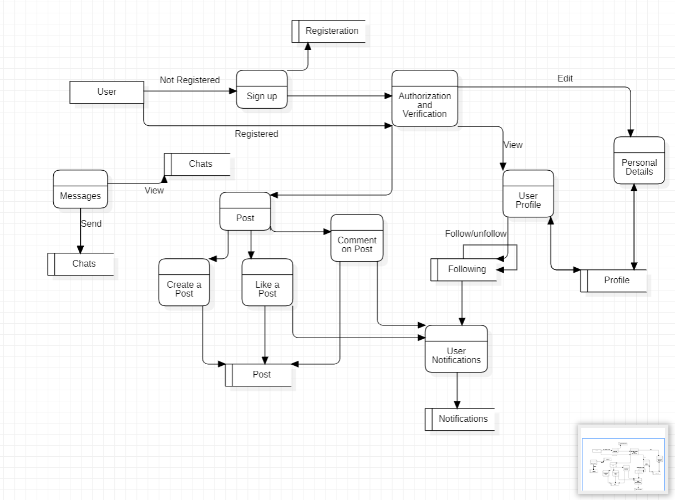

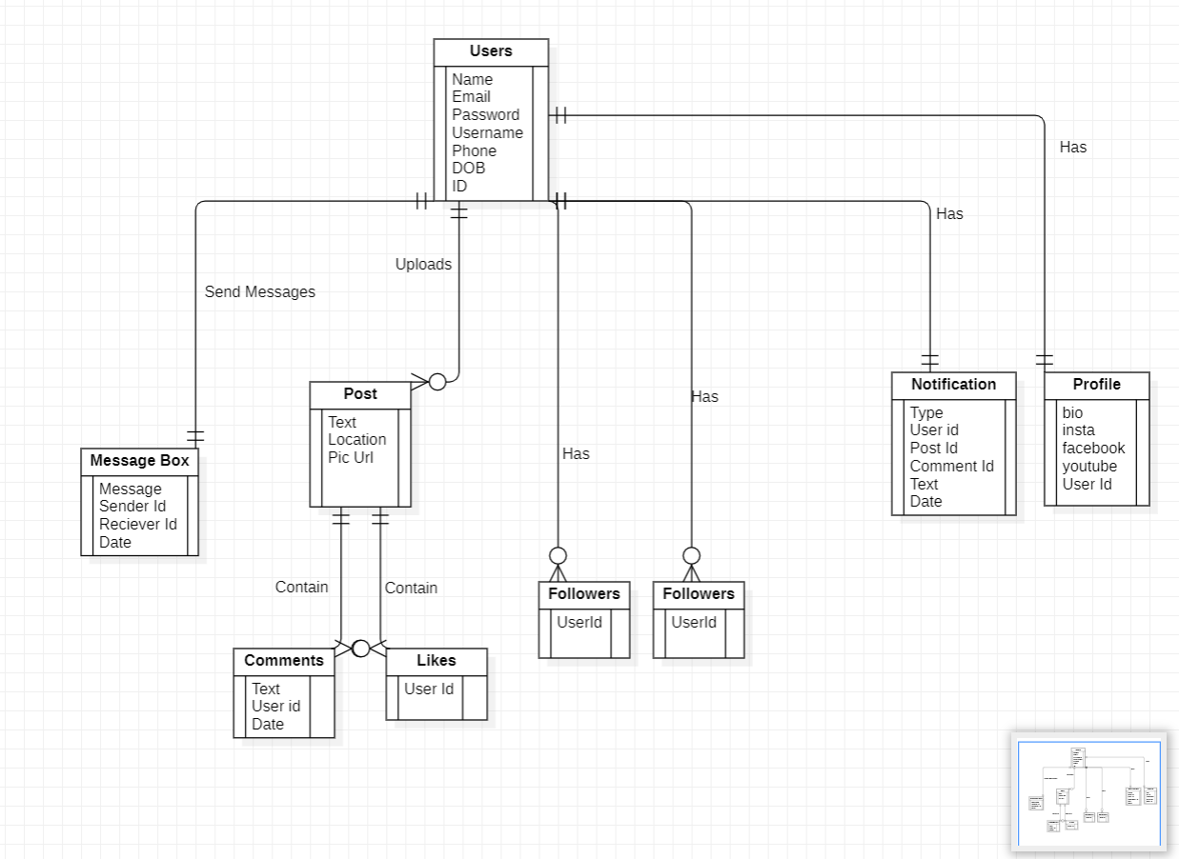**E-R DIAGRAM**

**TESTING**

## T ES T C A S E -1

TEST NO. 1

TEST TYPE : Unit Testing

INPUT : Password

OBJECTIVE : Checking Password Security

EXPECTED OUTPUT: Access to Authorized Users Only

ACTUAL OUTPUT : Password Security Successful

RESULT : Access to Only Authorized Users

## T E S T C A S E -2

TEST NO. 2

TEST TYPE UNIT TESTING

INPUT : Password during Registration.

OBJECTIVE : Password must contain at least one lower case, one upper case , one numeric and one special character

EXPECTED OUTPUT : ERROR MESSAGE

ACTUAL OUTPUT : ERROR MESSAGE

RESULT : Password must contain at least one lower case, one upper case ,one numeric and special character

## T E S T C A S E -3

TEST NO. 3

TEST TYPE UNIT TESTING

INPUT : Username during Registration.

OBJECTIVE : Username should be unique and contain only alphanumeric and underscore.

EXPECTED OUTPUT : ERROR MESSAGE

ACTUAL OUTPUT : ERROR MESSAGE

RESULT : Username is already taken.

**CONCLUSION**

So we conclude that in this project user is authenticated before making the entry to the network and have the privilege to communicate , with other users and share thoughts , ideas, and information through the virtual networks .

It is internet-based and gives users quick content. Content includes personal information, documents, and photos.

Users engage with social media, often utilizing it for messaging.

So it is the perfect and the secure way of self presentational and to connect people and a good social tool.

A large number of corner cases have been covered in the source code making it less likely to cause problem in case of abnormal input this makes it handy and reduce user dependency for its working

**Future Work :-** 1. Developing the channels so that users can chat in group.

2. Introducing voice group chat so that users can have group calls and have fun in realtime.

3. Implementing friend recommendation system based on mutual connections.

4. Implementing Real time notifications using socket io.

**REFERENCES**

**Source Code** [**https://github.com/varunkmr038/Clubhouse**](https://github.com/varunkmr038/Clubhouse)

[**https://en.wikipedia.org/wiki/Social_media**](https://en.wikipedia.org/wiki/Social_media)

[**https://www.geeksforgeeks.org/mern-stack/**](https://www.geeksforgeeks.org/mern-stack/)

[**https://www.javatpoint.com/software-requirement-specifications**](https://www.javatpoint.com/software-requirement-specifications)

[**https://www.tutorialspoint.com/socket.io/index.htm**](https://www.tutorialspoint.com/socket.io/index.htm)

[**https://www.tutorialspoint.com/mongodb/index.htm**](https://www.tutorialspoint.com/mongodb/index.htm)

[**https://medium.com/code-dementia/building-a-social-network-using-mern-stack-85037914b944**](https://medium.com/code-dementia/building-a-social-network-using-mern-stack-85037914b944)

[**https://en.wikipedia.org/wiki/Data-flow_diagram**](https://en.wikipedia.org/wiki/Data-flow_diagram)